In a course on memory management we obviously need to take a look at the available memory types in computer systems. Below you will find a small list of some common memory types that you will surely have heard of:

* RAM / ROM
* Cache (L1, L2)
* Registers
* Virtual Memory
* Hard Disks, USB drives

Let us look into these types more deeply: When the CPU of a computer needs to access memory, it wants to do this with minimal latency. Also, as large amounts of information need to be processed, the available memory should be sufficiently large with regard to the tasks we want to accomplish.

Regrettably though, low latency and large memory are not compatible with each other (at least not at a reasonable price). In practice, the decision for low latency usually results in a reduction of the available storage capacity (and vice versa). This is the reason why a computer has multiple memory types that are arranged hierarchically. The following pyramid illustrates the principle:

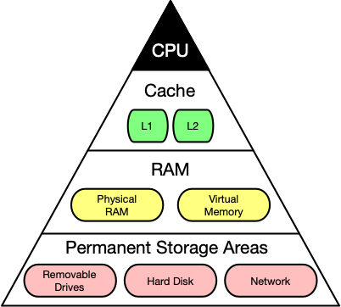

As you can see, the CPU and its ultra-fast (but small) registers used for short-term data storage reside at the top of the pyramid. Below are Cache and RAM, which belong to the category of temporary memory which quickly looses its content once power is cut off. Finally, there are permanent storage devices such as the ROM, hard drives as well as removable drives such as USB sticks.

Let us take a look at a typical computer usage scenario to see how the different types of memory are used:

1. After switching on the computer, it loads data from its read-only memory (ROM) and performs a power-on self-test (POST) to ensure that all major components are working properly. Additionally, the computer memory controller checks all of the memory addresses with a simple read/write operation to ensure that memory is functioning correctly.
2. After performing the self-test, the computer loads the basic input/output system (BIOS) from ROM. The major task of the BIOS is to make the computer functional by providing basic information about such things as storage devices, boot sequence, security or auto device recognition capability.
3. The process of activating a more complex system on a simple system is called "bootstrapping": It is a solution for the chicken-egg-problem of starting a software-driven system by itself using software. During bootstrapping, the computer loads the operating system (OS) from the hard drive into random access memory (RAM). RAM is considered "random access" because any memory cell can be accessed directly by intersecting the respective row and column in the matrix-like memory layout. For performance reasons, many parts of the OS are kept in RAM as long as the computer is powered on.
4. When an application is started, it is loaded into RAM. However, several application components are only loaded into RAM on demand to preserve memory. Files that are opened during runtime are also loaded into RAM. When a file is saved, it is written to the specified storage device. After closing the application, it is deleted from RAM.

This simple usage scenario shows the central importance of the RAM. Every time data is loaded or a file is opened, it is placed into this temporary storage area - but what about the other memory types above the RAM layer in the pyramid?

To maximize CPU performance, fast access to large amounts of data is critical. If the CPU cannot get the data it needs, it stops and waits for data availability. Thus, when designing new memory chips, engineers must adapt to the speed of the available CPUs. The problem they are facing is that memory which is able to keep up with modern CPUs running at several GHz is extremely expensive. To combat this, computer designers have created the memory tier system which has already been shown in the pyramid diagram above. The solution is to use expensive memory in small quantities and then back it up using larger quantities of less expensive memory.

The cheapest form of memory available today is the hard disk. It provides large quantities of inexpensive and permanent storage. The problem of a hard disk is its comparatively low speed - even though access times with modern solid state disks (SSD) have decreased significantly compared to older magnetic-disc models.

The next hierarchical level above hard disks or other external storage devices is the RAM. We will not discuss in detail how it works but only take a look at some key performance metrics of the CPU at this point, which place certain performance expectations on the RAM and its designers:

1. The **bit size** of the CPU decides how many bytes of data it can access in RAM memory at the same time. A 16-bit CPU can access 2 bytes (with each byte consisting of 8 bit) while a 64-bit CPU can access 8 bytes at a time.
2. The **processing speed** of the CPU is measured in Gigahertz or Megahertz and denotes the number of operations it can perform in one second.

From processing speed and bit size, the data rate required to keep the CPU busy can easily be computed by multiplying bit size with processing speed. With modern CPUs and ever-increasing speeds, the available RAM in the market will not be fast enough to match the CPU data rate requirements.

Extra Resources:

<https://superuser.com/questions/593847/how-many-memory-addresses-can-we-get-with-a-32-bit-processor-and-1gb-ram>